SQL Lesson 1: SELECT queries 101
1. Find the title of each film
SELECT title FROM movies;
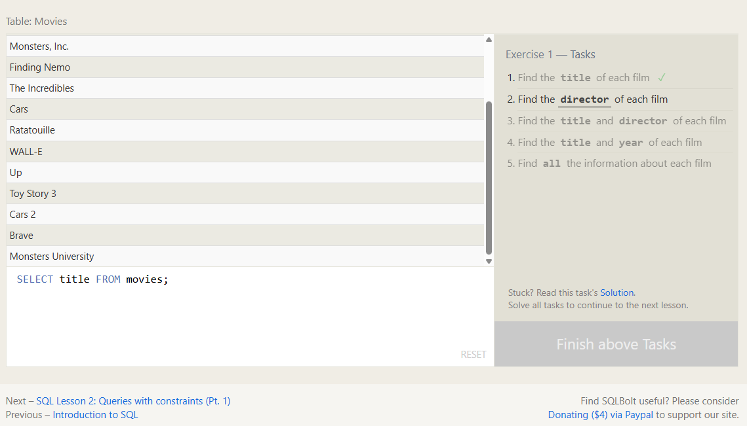
2. Find the director of each film
SELECT director FROM movies;
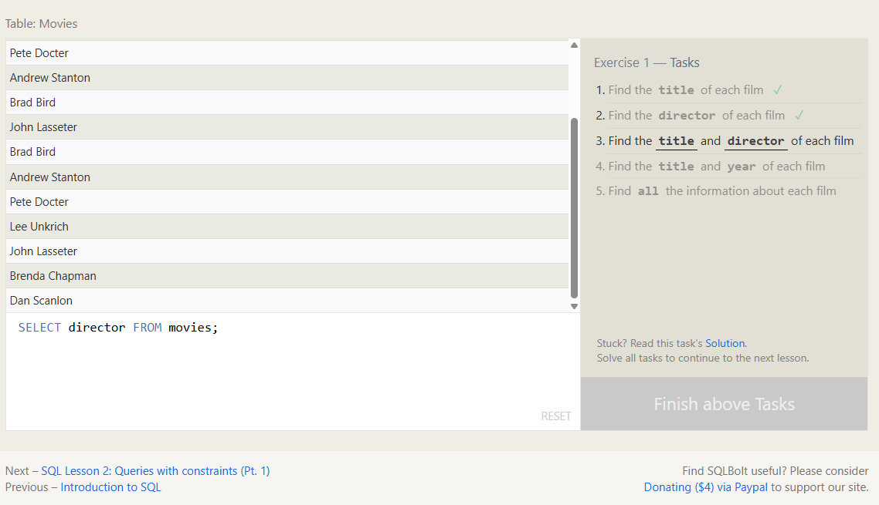
3. Find the title and director of each film
SELECT title, director FROM movies;
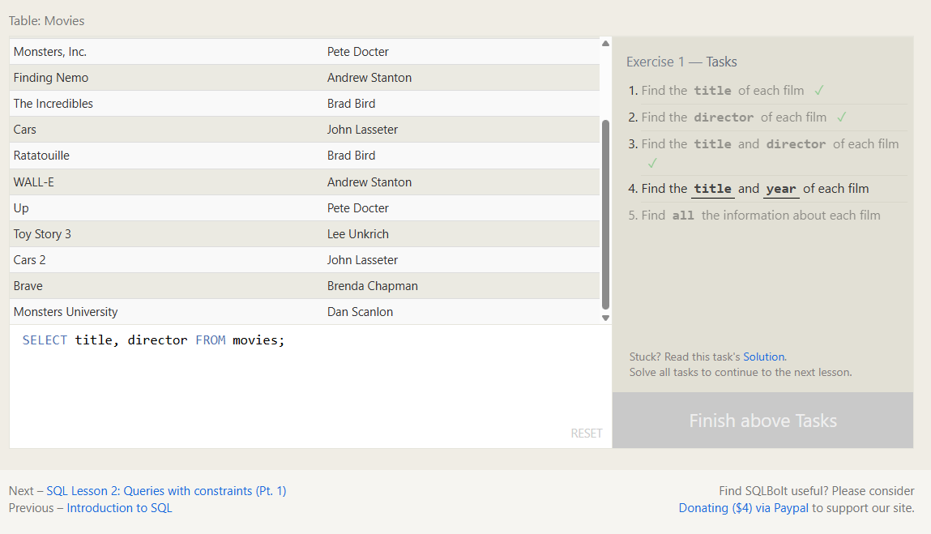
4. Find the title and year of each film
SELECT title, year FROM movies;
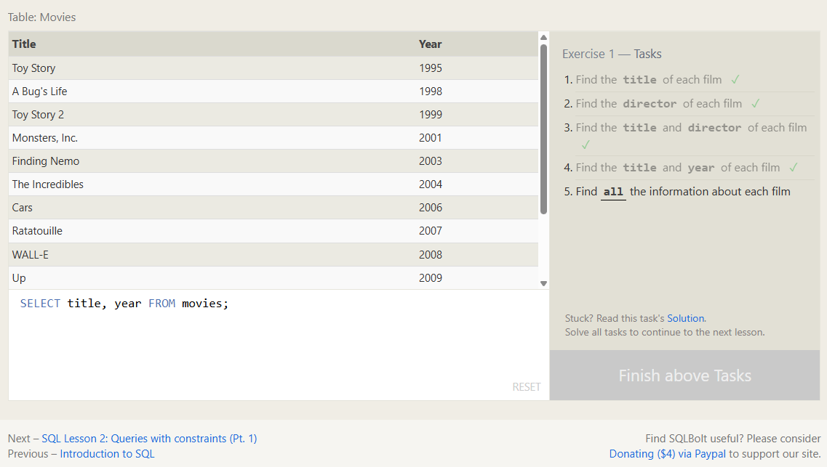
5. Find all the information about each film
SELECT * FROM movies;
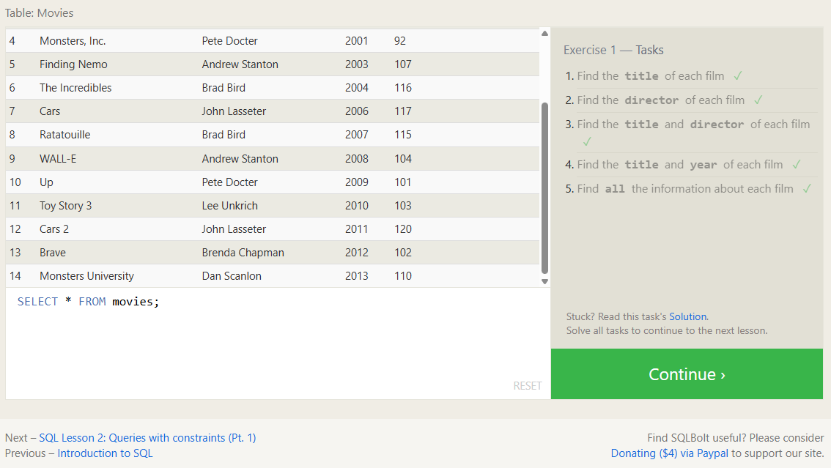

SQL Lesson 2: Queries with constraints (Pt. 1)
1. Find the movie with a row id of 6
SELECT * FROM movies
WHERE id = 6;
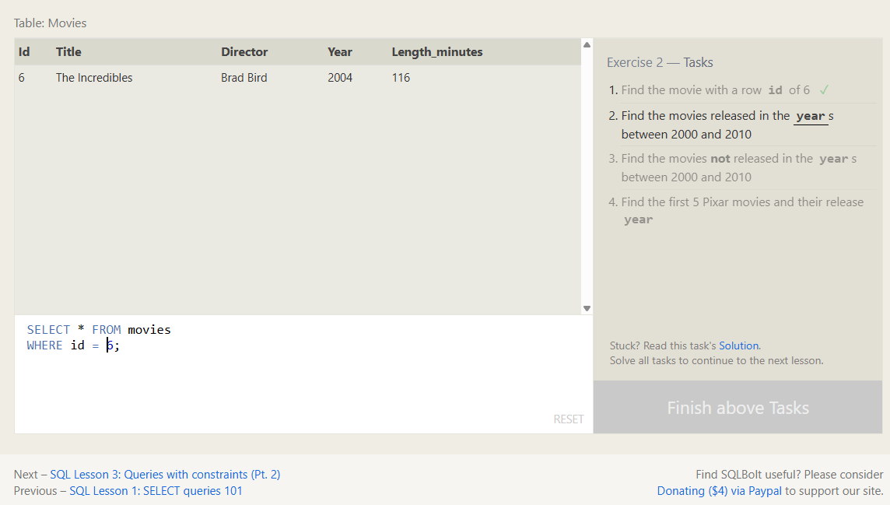
2. Find the movies released in the years between 2000 and 2010
SELECT * FROM movies
WHERE year BETWEEN 2000 AND 2010;
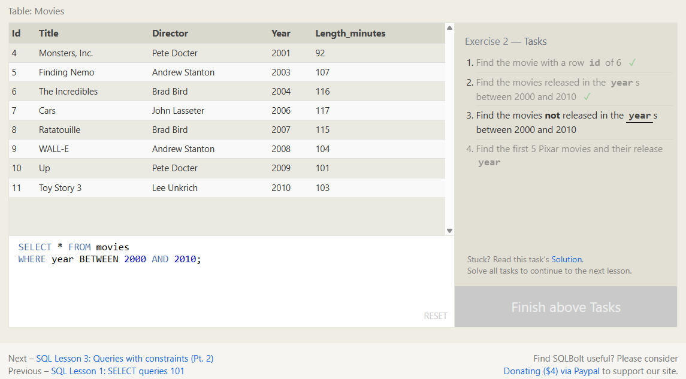
3. Find the movies not released in the years between 2000 and 2010
SELECT * FROM movies
WHERE year NOT BETWEEN 2000 AND 2010;
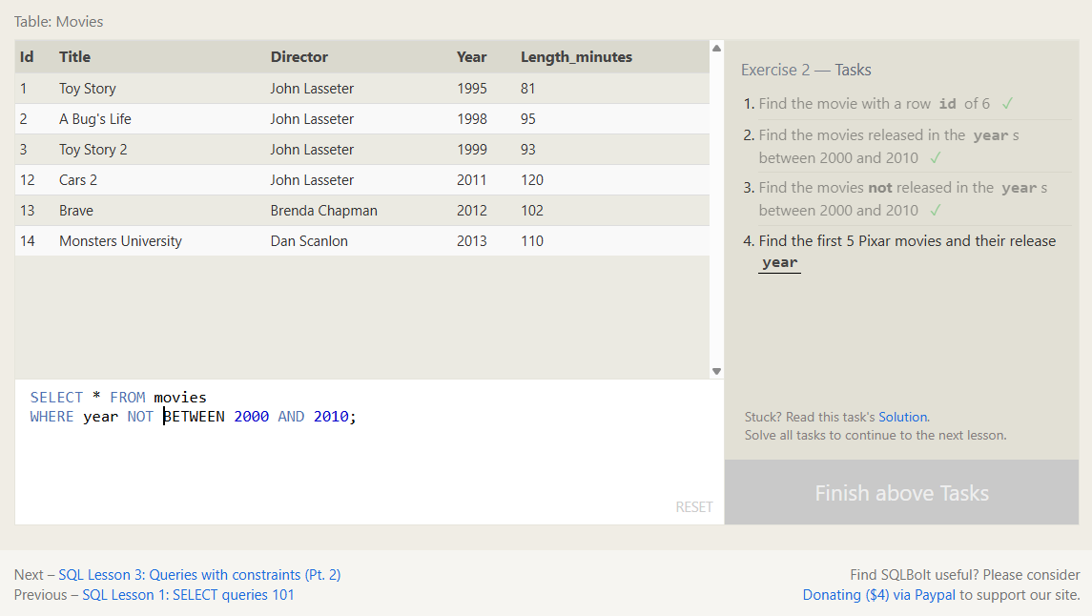
4. Find the first 5 Pixar movies and their release year
SELECT title, year FROM movies
ORDER BY year
LIMIT 5;
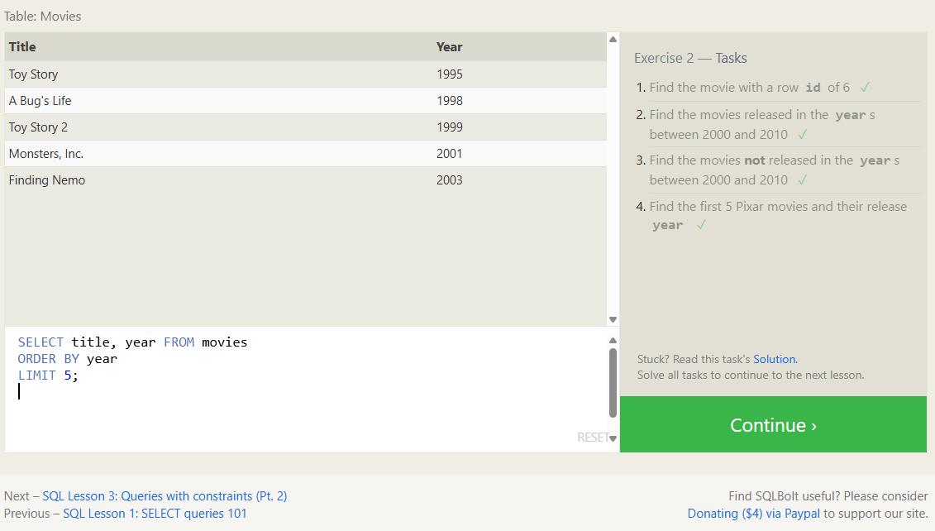

SQL Lesson 3: Queries with constraints (Pt. 2)
1. Find all the Toy Story movies
SELECT * FROM movies
WHERE title LIKE 'Toy Story%';
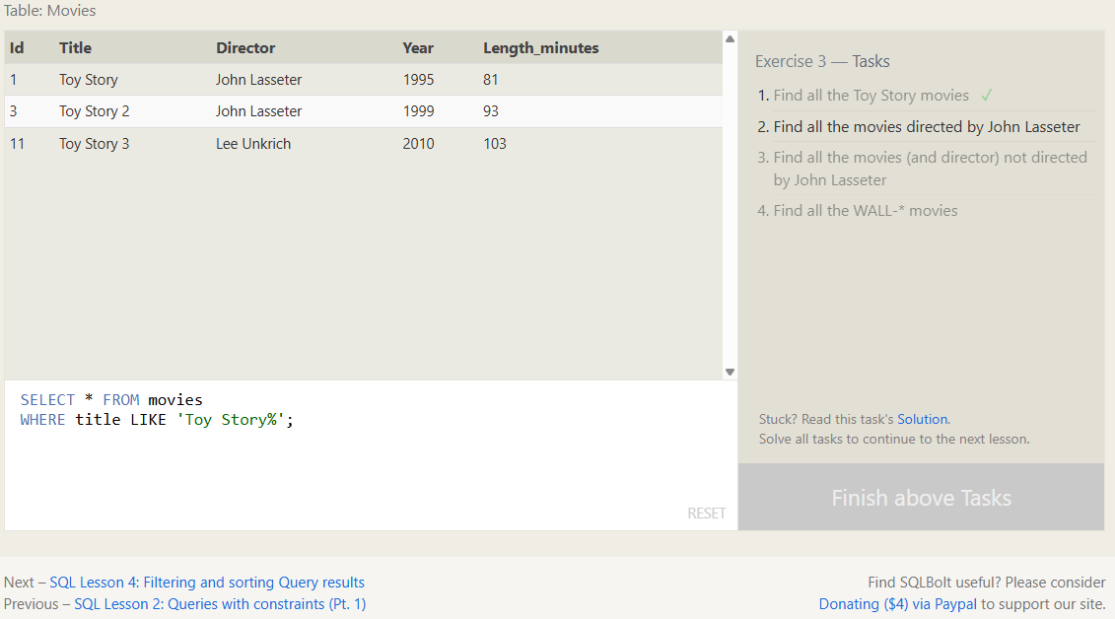
2. Find all the movies directed by John Lasseter
SELECT * FROM movies
WHERE director = 'John Lasseter';
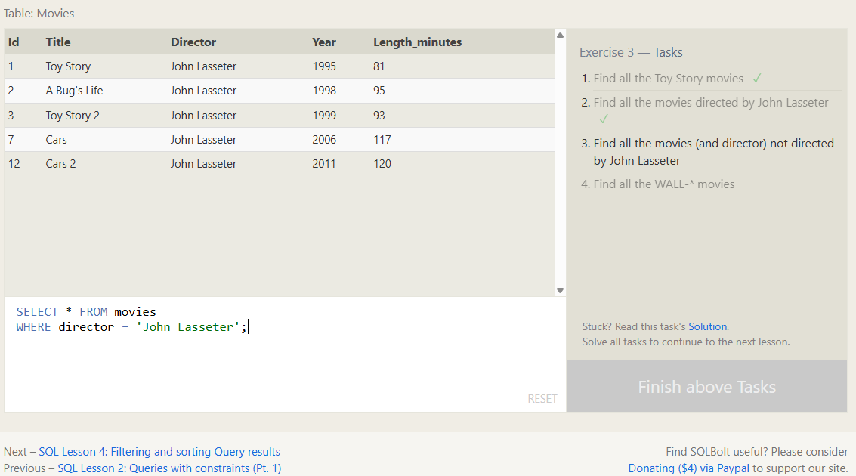
3. Find all the movies (and director) not directed by John Lasseter
SELECT * FROM movies
WHERE director != 'John Lasseter';
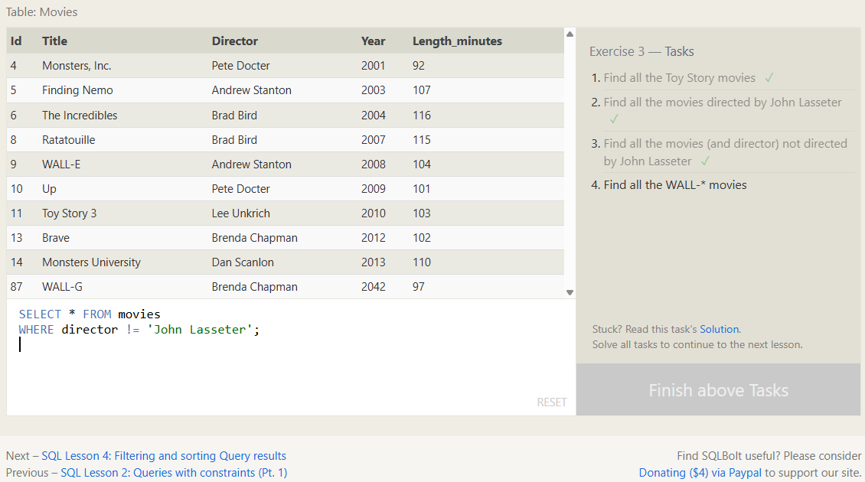
4. Find all the WALL-* movies
SELECT * FROM movies
WHERE title LIKE 'WALL-%';
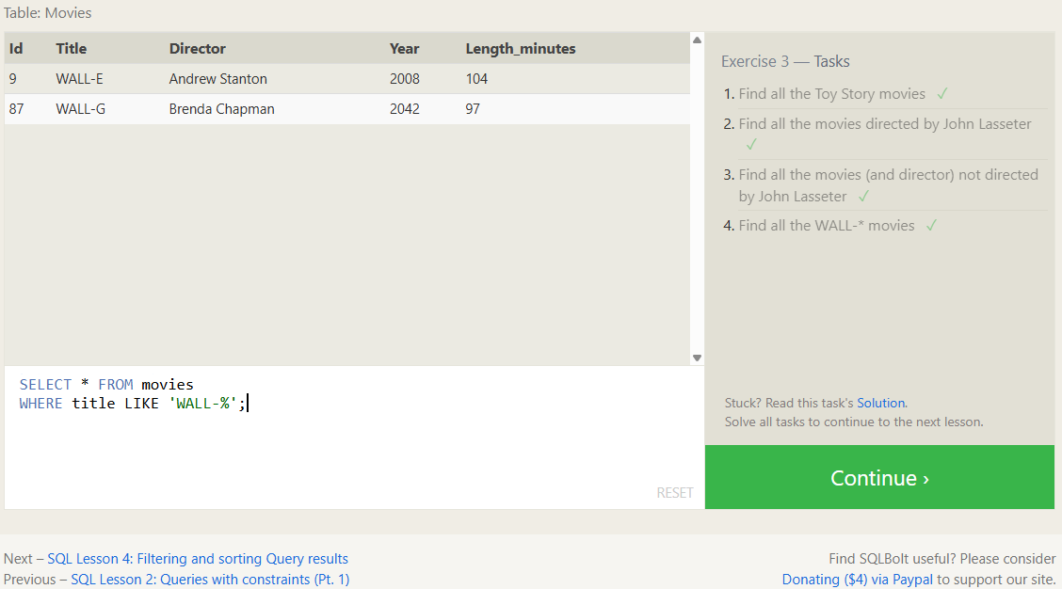

SQL Lesson 4: Filtering and sorting Query results
1. List all directors of Pixar movies (alphabetically), without duplicates
SELECT DISTINCT director FROM movies
ORDER BY director;
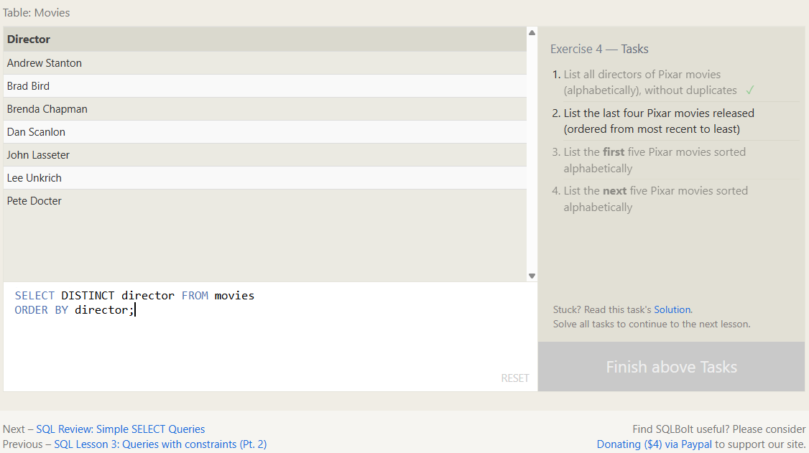
2. List the last four Pixar movies released (ordered from most recent to least)
SELECT * FROM movies
ORDER BY year DESC
LIMIT 4;
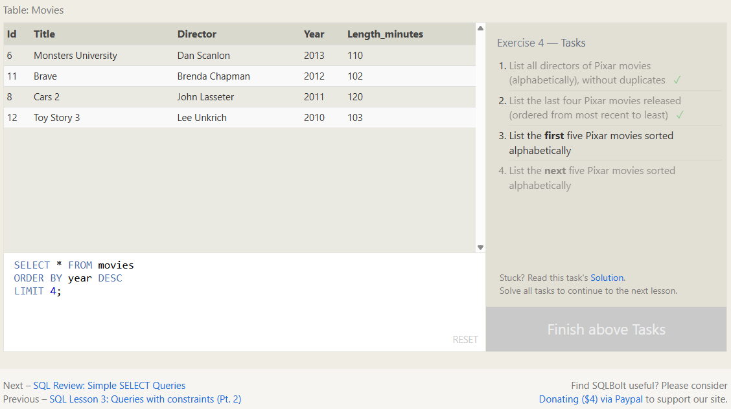
3. List the first five Pixar movies sorted alphabetically
SELECT * FROM movies
ORDER BY title
LIMIT 5;
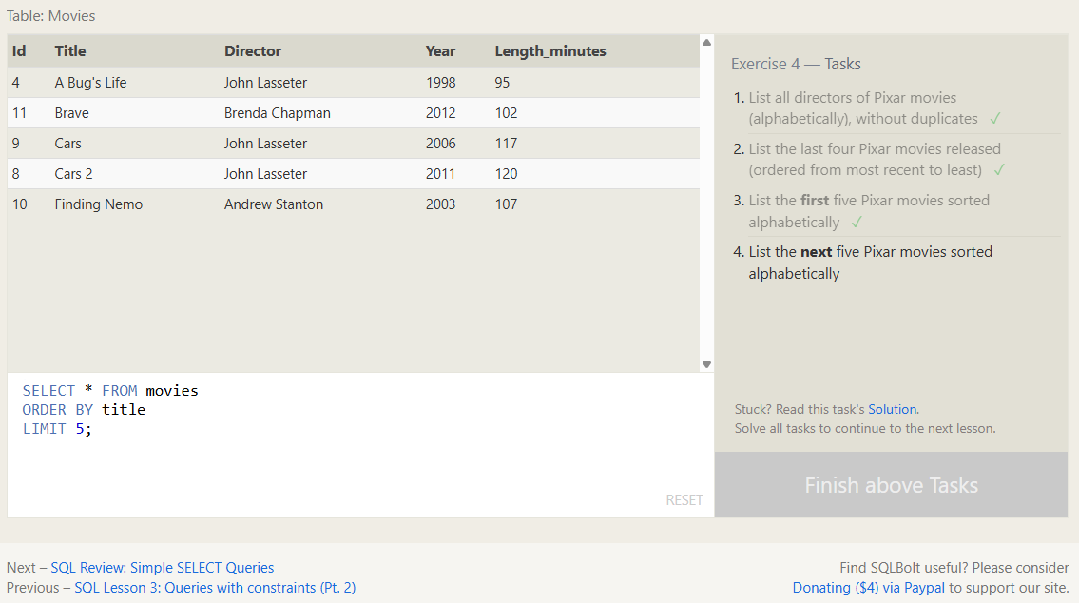
4. List the next five Pixar movies sorted alphabetically
SELECT * FROM movies
ORDER BY title ASC
LIMIT 5 OFFSET 5;
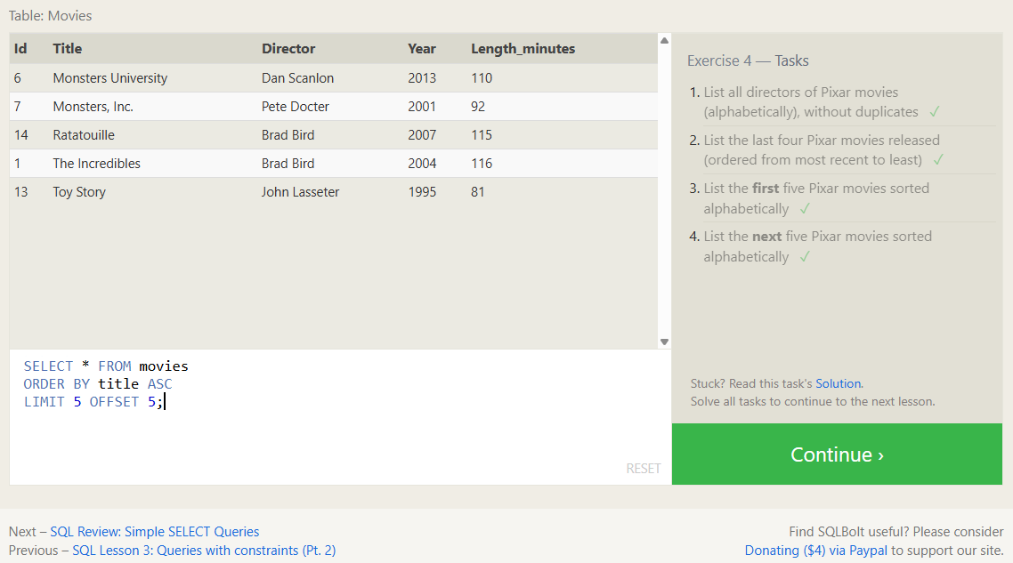

SQL Review: Simple SELECT Queries
1. List all the Canadian cities and their populations
SELECT city, population FROM north_american_cities
WHERE country = 'Canada';
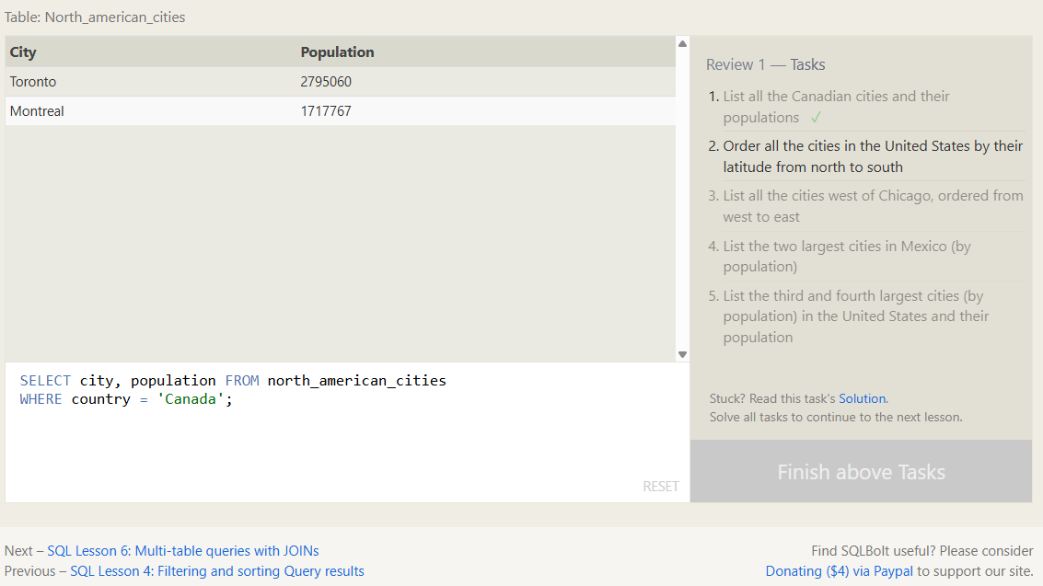
2. Order all the cities in the United States by their latitude from north to south
SELECT city FROM north_american_cities
WHERE country = 'United States'
ORDER BY latitude DESC;
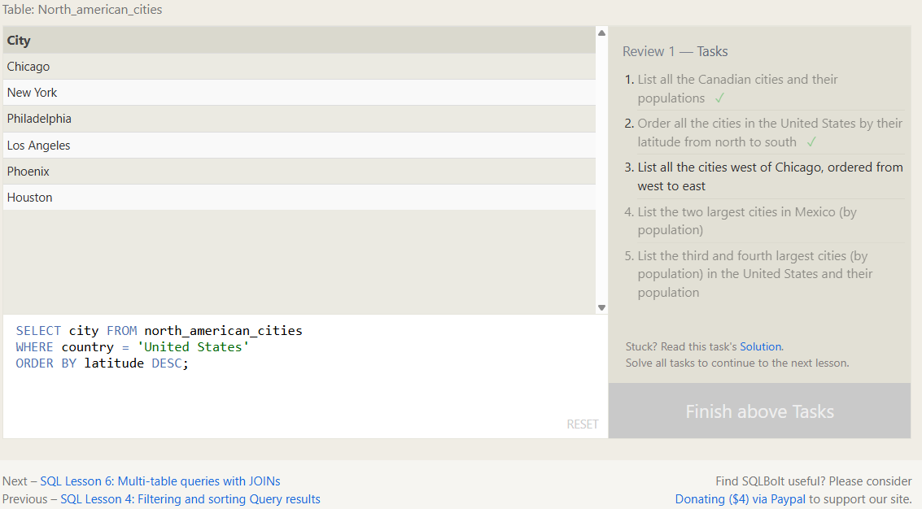
3. List all the cities west of Chicago, ordered from west to east
SELECT city FROM north_american_cities
WHERE longitude < (
SELECT longitude FROM north_american_cities WHERE city = 'Chicago')
ORDER BY longitude;
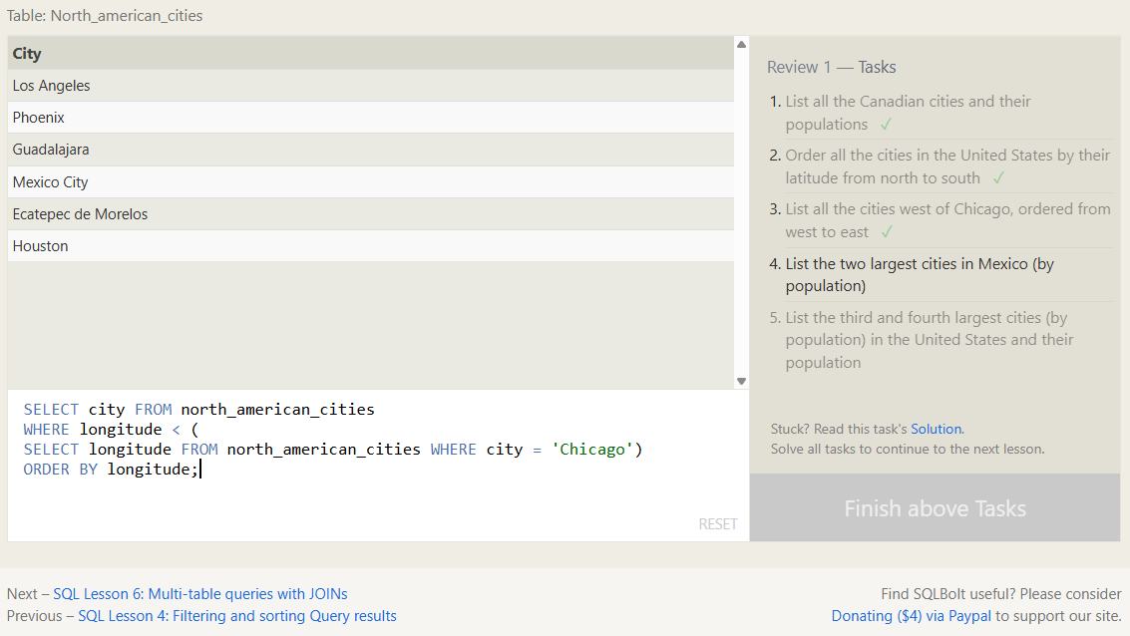
4. List the two largest cities in Mexico (by population)
SELECT city, population FROM north_american_cities
WHERE country = 'Mexico'
ORDER BY population DESC
LIMIT 2;
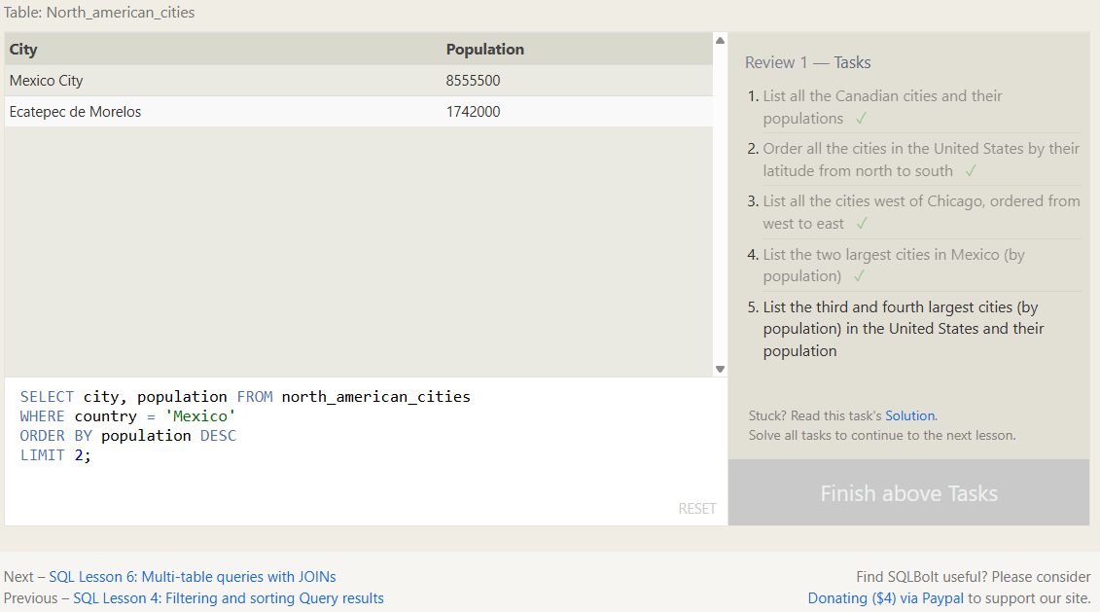
5. List the third and fourth largest cities (by population) in the United States and their population
SELECT city, population FROM north_american_cities
WHERE country = 'United States'
ORDER BY population DESC
LIMIT 2 OFFSET 2;
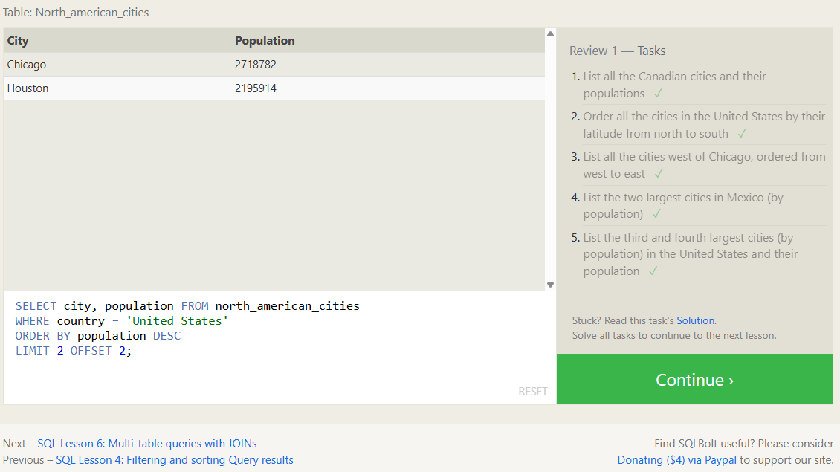

SQL Lesson 6: Multi-table queries with JOINs
1. Find the domestic and international sales for each movie
SELECT title, domestic_sales, international_sales FROM movies
INNER JOIN boxoffice
ON movies.id = movie_id;
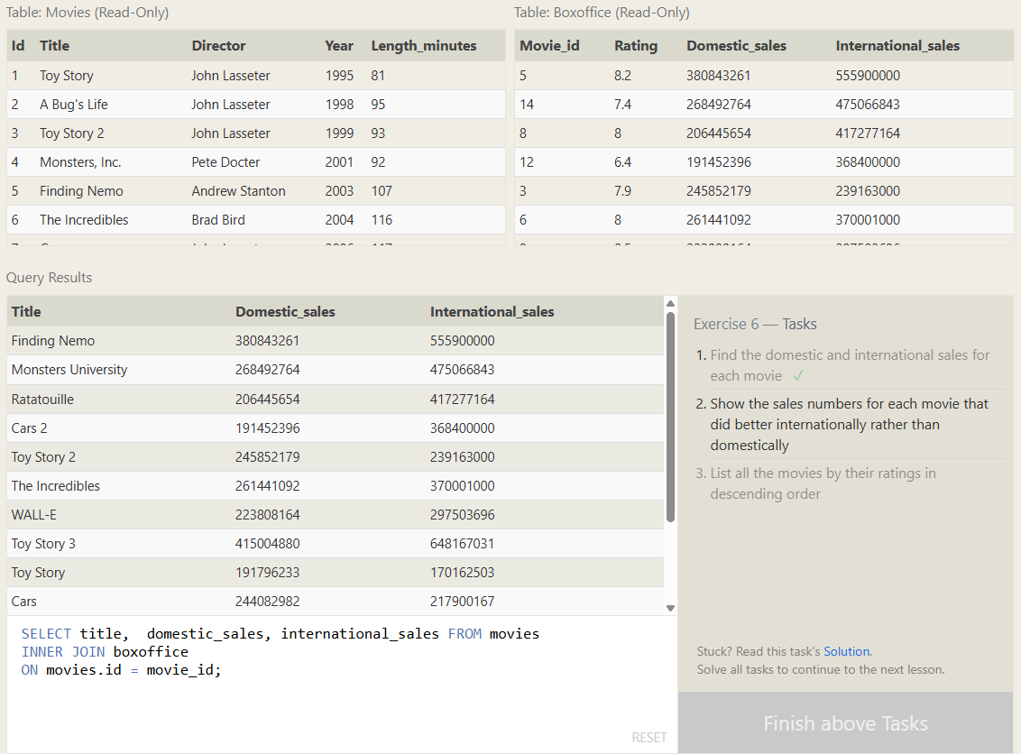
2. Show the sales numbers for each movie that did better internationally rather than domestically
SELECT title, domestic_sales, international_sales FROM movies
INNER JOIN boxoffice
ON movies.id = movie_id
WHERE international_sales > domestic_sales;
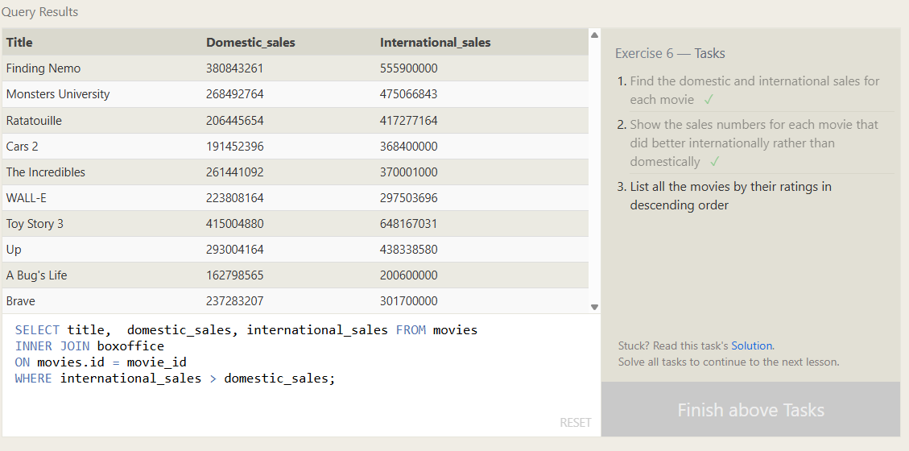
3. List all the movies by their ratings in descending order
SELECT title, rating FROM movies
INNER JOIN boxoffice
ON movies.id = movie_id
ORDER BY rating DESC;
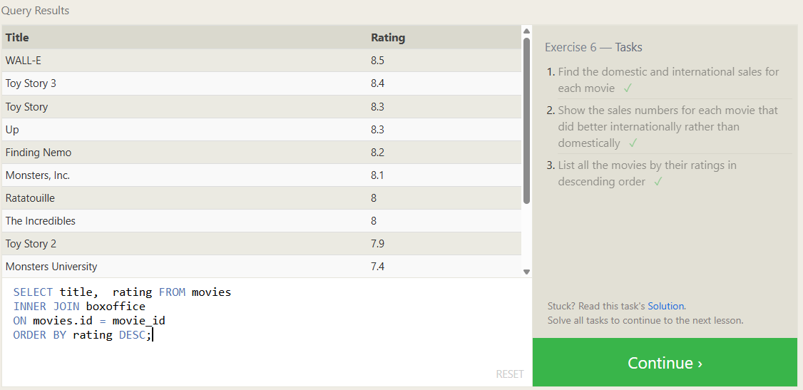

SQL Lesson 7: OUTER JOINs
1. Find the list of all buildings that have employees
SELECT DISTINCT building_name FROM buildings
LEFT JOIN employees
ON buildings.building_name = employees.building
WHERE employees.building IS NOT NULL;
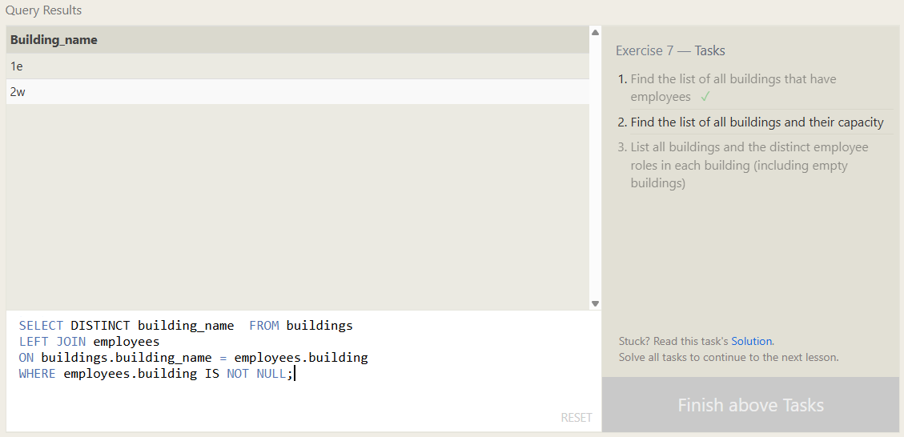
2. Find the list of all buildings and their capacity
SELECT building_name, capacity FROM buildings;
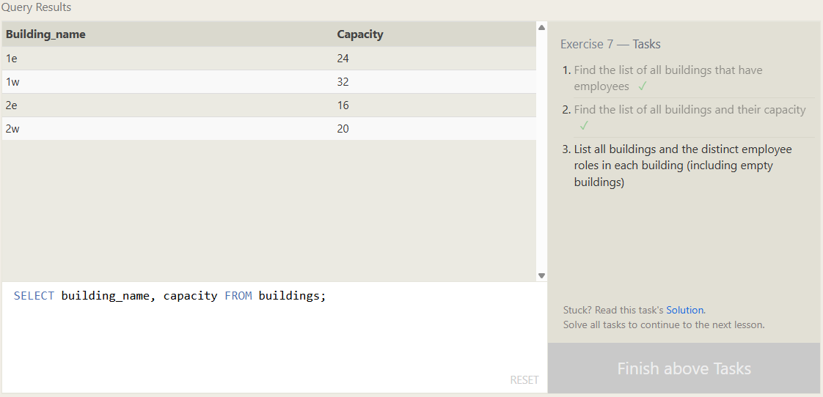
3. List all buildings and the distinct employee roles in each building (including empty buildings)
SELECT DISTINCT building_name, role FROM buildings
LEFT JOIN employees ON buildings.building_name = employees.building;
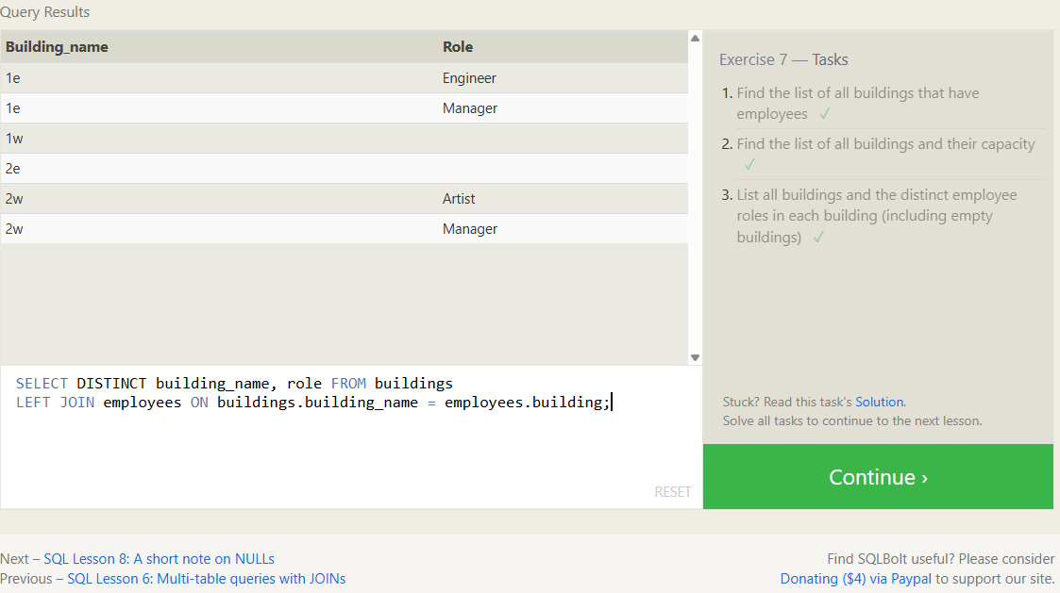

SQL Lesson 8: A short note on NULLs
1. Find the name and role of all employees who have not been assigned to a building
SELECT name, role FROM employees
WHERE building IS NULL;
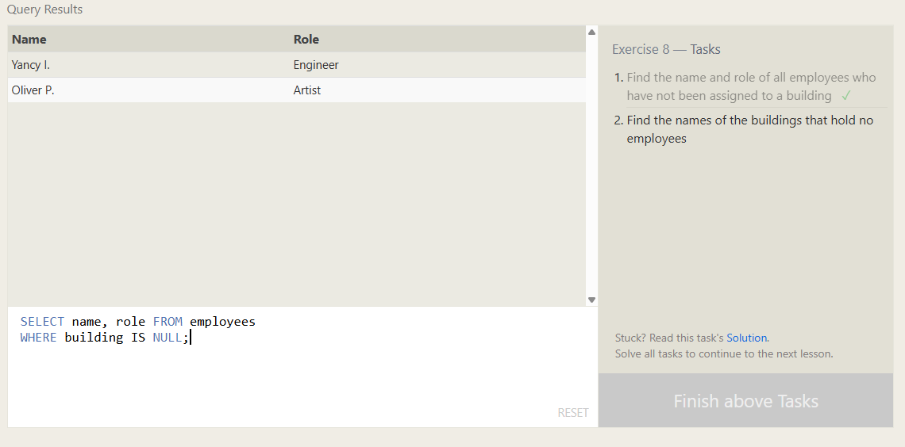
2. Find the names of the buildings that hold no employees
SELECT building_name FROM buildings
LEFT JOIN employees ON buildings.building_name = employees.building
WHERE building IS NULL;
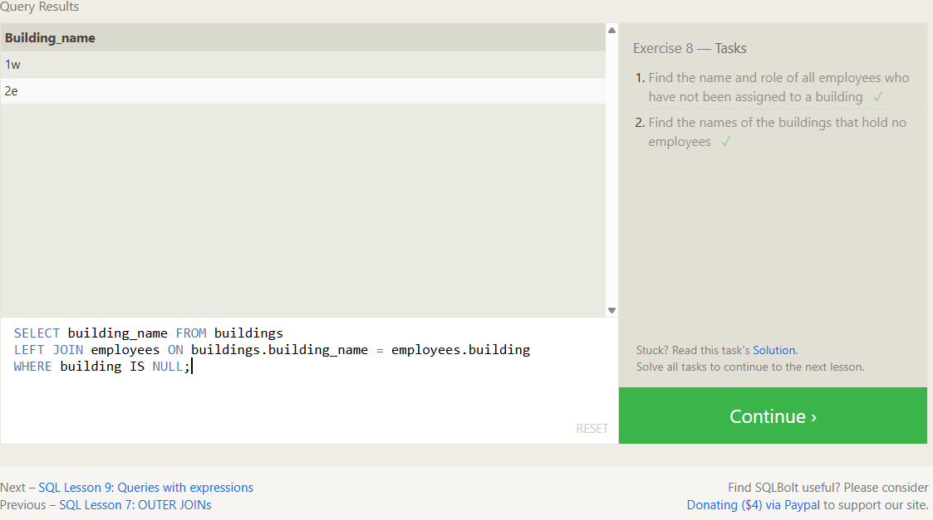

SQL Lesson 9: Queries with expressions
1. List all movies and their combined sales in millions of dollars
SELECT title,
(domestic_sales + international_sales) / 1000000 as combined_sales
FROM movies
INNER JOIN boxoffice ON movies.id = boxoffice.movie_id;
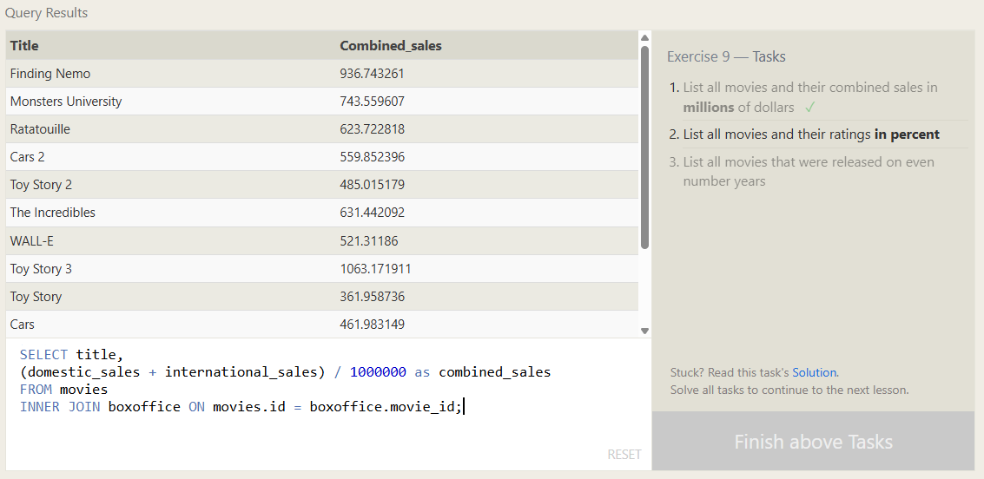
2. List all movies and their ratings in percent
SELECT title, (rating * 10) as rating_percent FROM movies
LEFT JOIN boxoffice ON movies.id = boxoffice.movie_id;
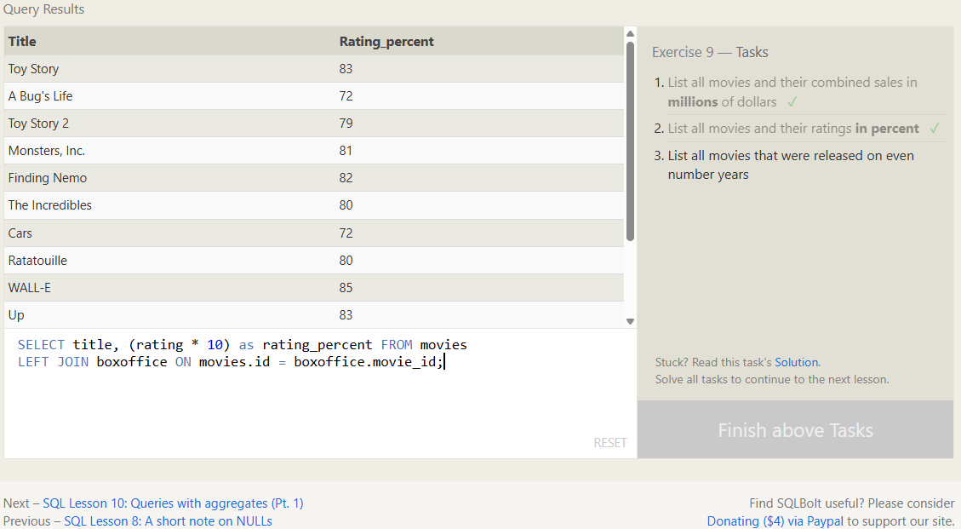
3. List all movies that were released on even number years
SELECT title, year FROM movies
WHERE year % 2 = 0;
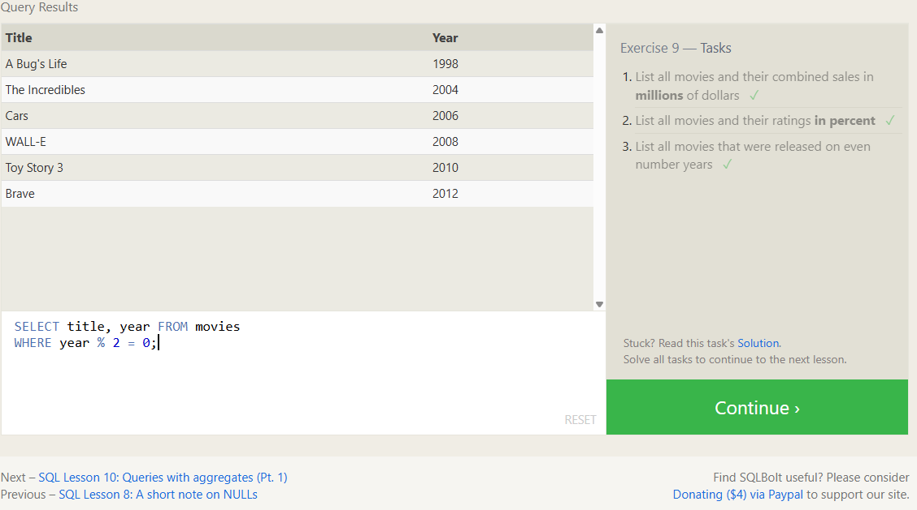

SQL Lesson 10: Queries with aggregates (Pt. 1)
1. Find the longest time that an employee has been at the studio
SELECT MAX(years_employed) FROM employees;
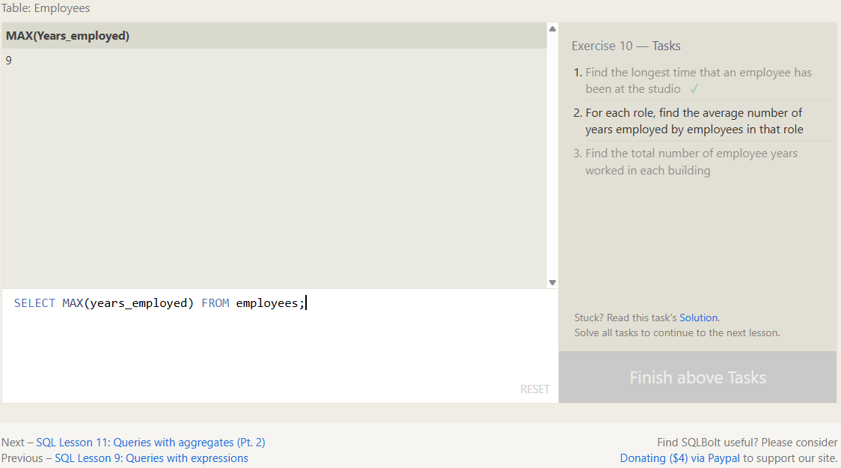
2. For each role, find the average number of years employed by employees in that role
SELECT role, AVG(years_employed) FROM employees
GROUP BY role;
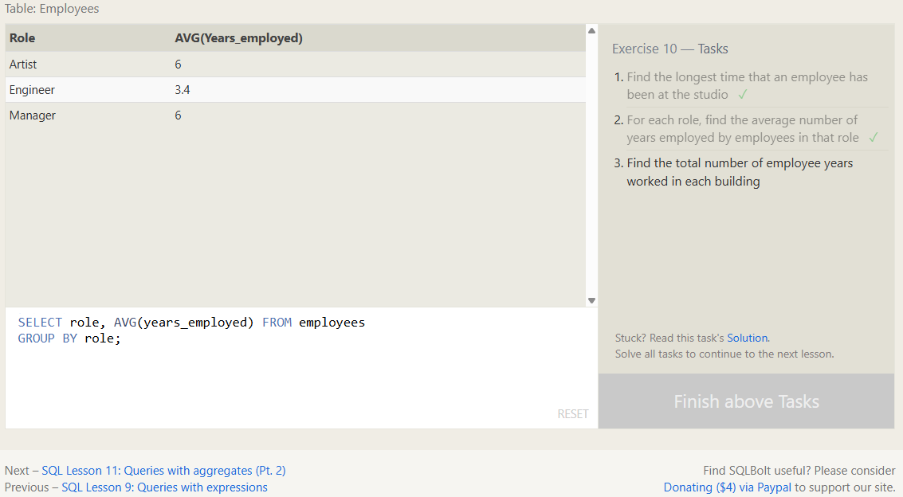
3. Find the total number of employee years worked in each building
SELECT building, SUM(years_employed) FROM employees
GROUP BY building;
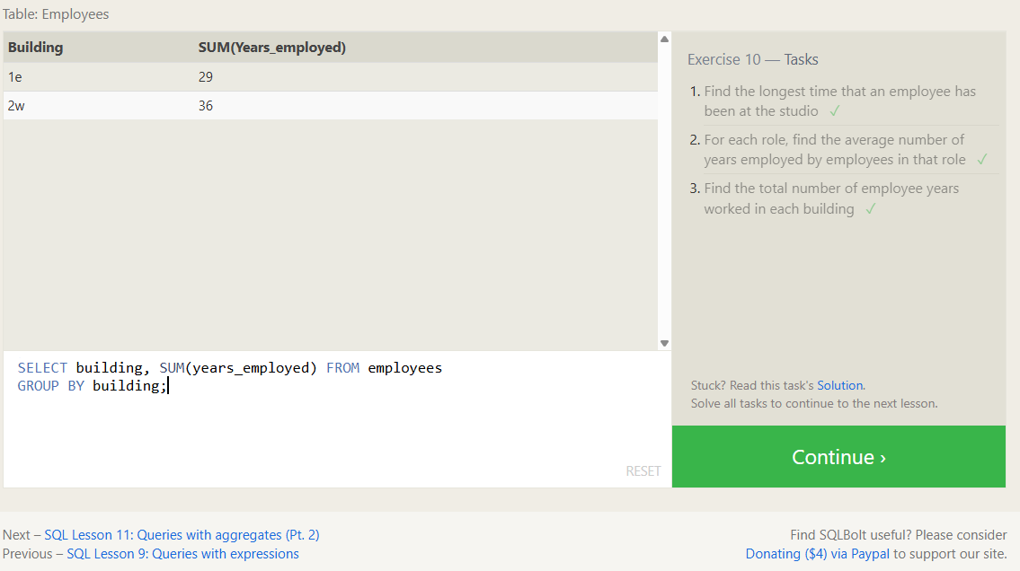

SQL Lesson 11: Queries with aggregates (Pt. 2)
1. Find the number of Artists in the studio (without a HAVING clause)
SELECT COUNT(*) FROM employees
WHERE role = 'Artist';
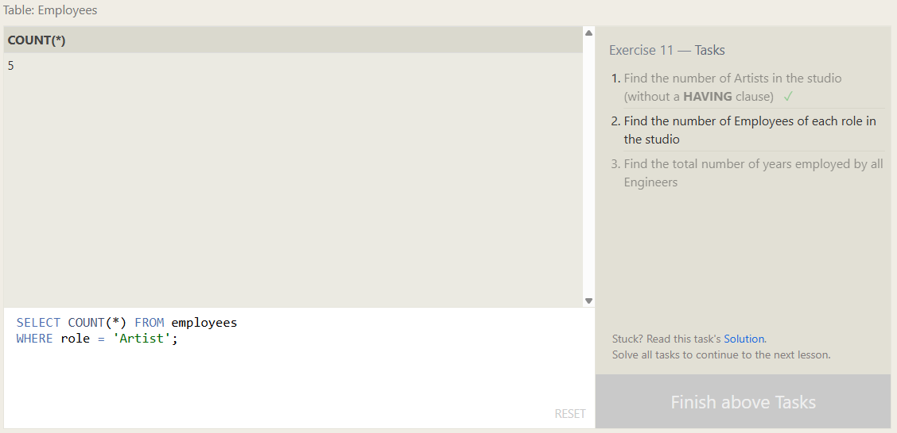
2. Find the number of Employees of each role in the studio
SELECT role, COUNT(*) FROM employees
GROUP BY role;
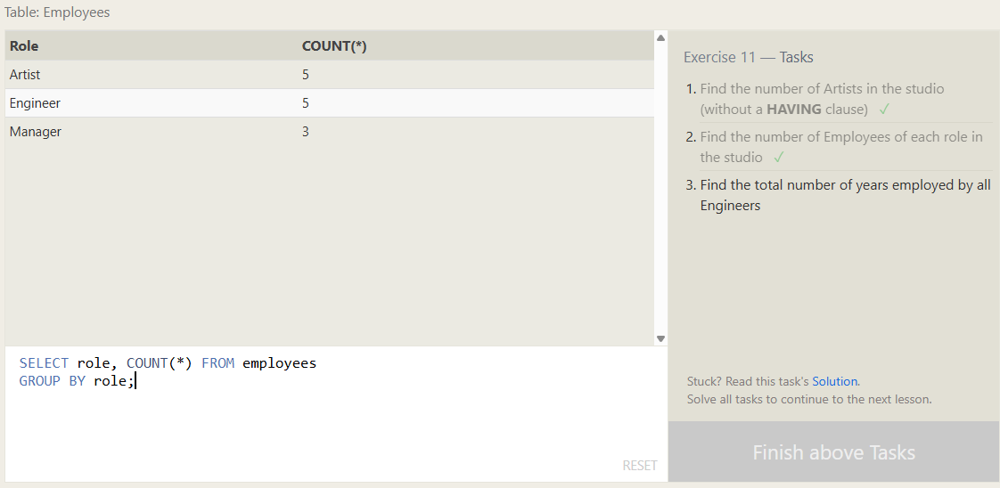
3. Find the total number of years employed by all Engineers
SELECT SUM(years_employed) FROM employees
WHERE role = 'Engineer';
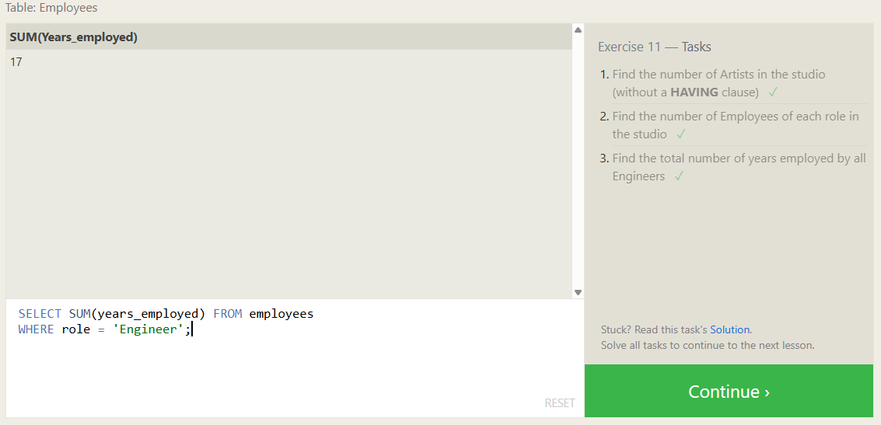

SQL Lesson 12: Order of execution of a Query
1. Find the number of movies each director has directed
SELECT director, COUNT(*) FROM movies
GROUP BY director;
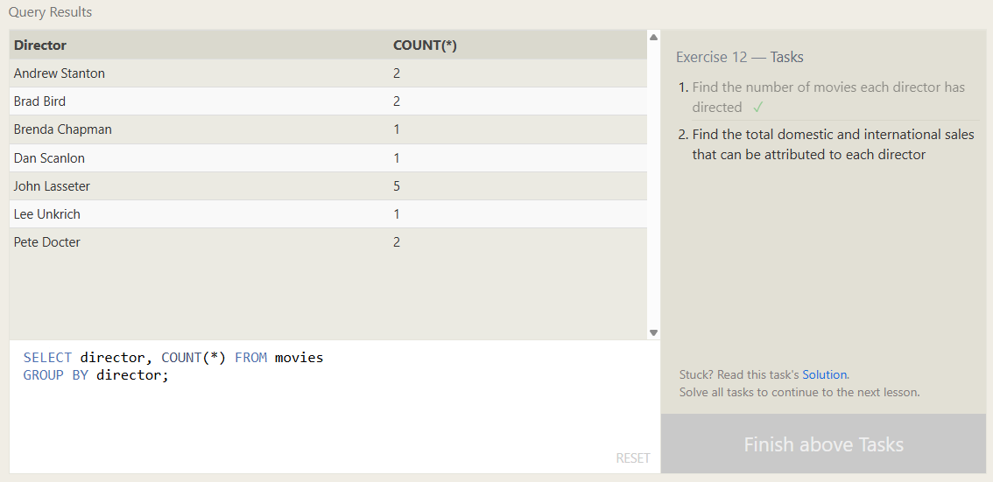
2. Find the total domestic and international sales that can be attributed to each director
SELECT director,
SUM(domestic_sales) + SUM(international_sales) AS total_sales FROM movies
INNER JOIN boxoffice ON movies.id = boxoffice.movie_id
GROUP BY director;
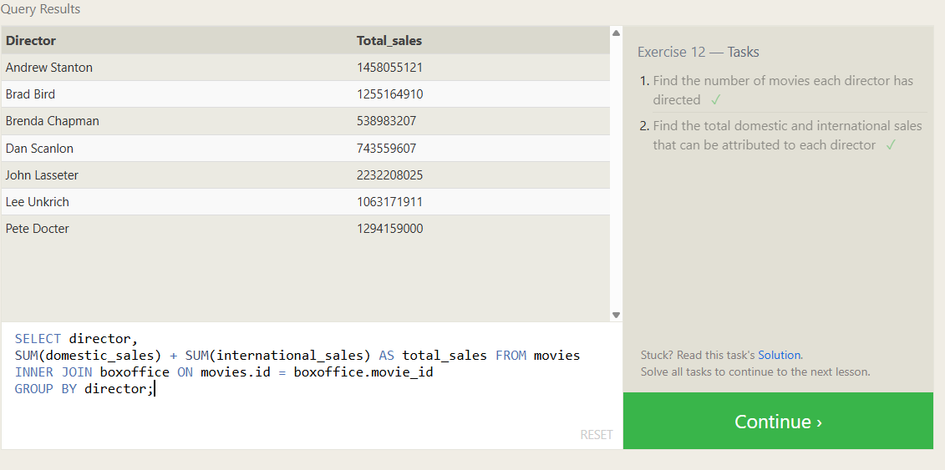

SQL Lesson 13: Inserting rows
1. Add the studio's new production, Toy Story 4 to the list of movies (you can use any director)
INSERT INTO movies (id, title, director, year, length_minutes)
VALUES (4, 'Toy Story 4', 'Lee Unkrich', 2019, 100);
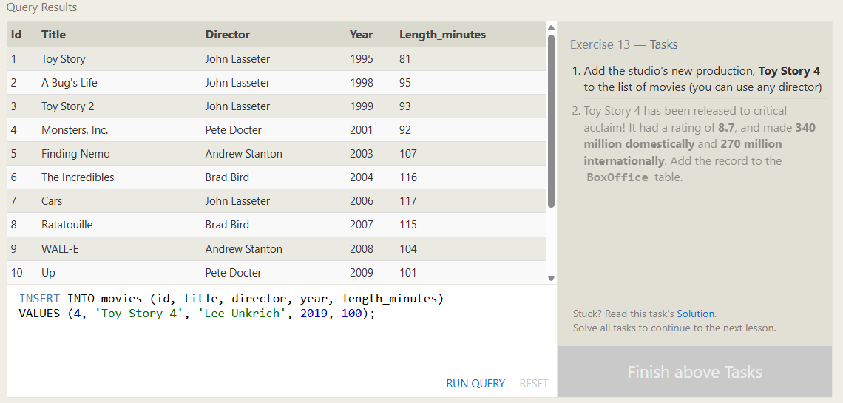
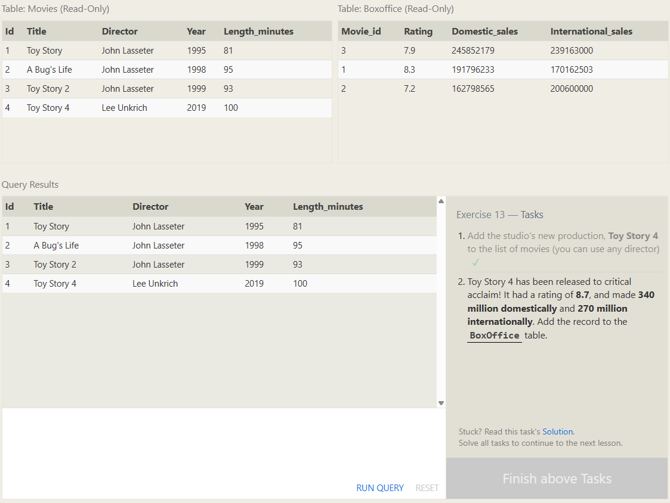
2. Toy Story 4 has been released to critical acclaim! It had a rating of 8.7, and made 340 million domestically and 270 million internationally. Add the record to the BoxOffice table.
INSERT INTO boxoffice (movie_id, rating, domestic_sales, international_sales)
VALUES (4, 8.7, 340, 270);
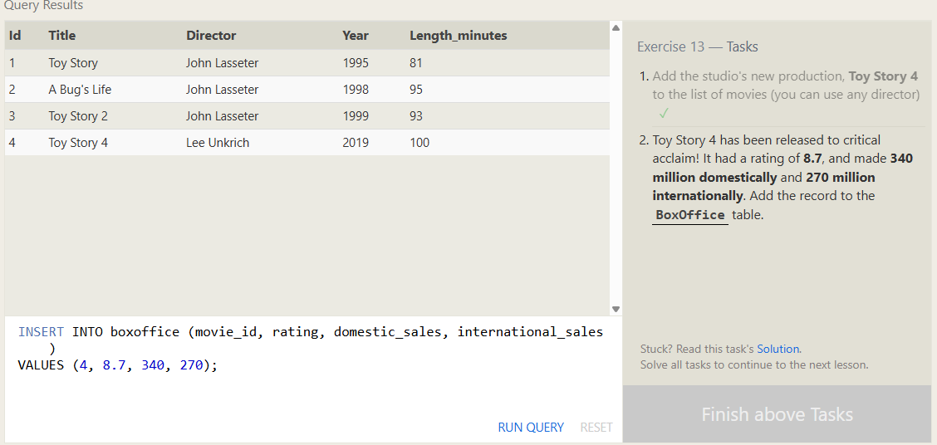
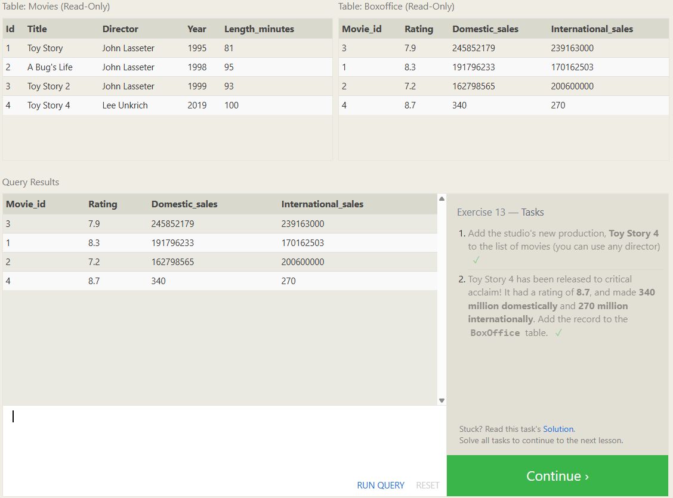

SQL Lesson 14: Updating rows
1. The director for A Bug's Life is incorrect, it was actually directed by John Lasseter
UPDATE movies
SET director = 'John Lasseter'
WHERE title = 'A Bug''s Life';
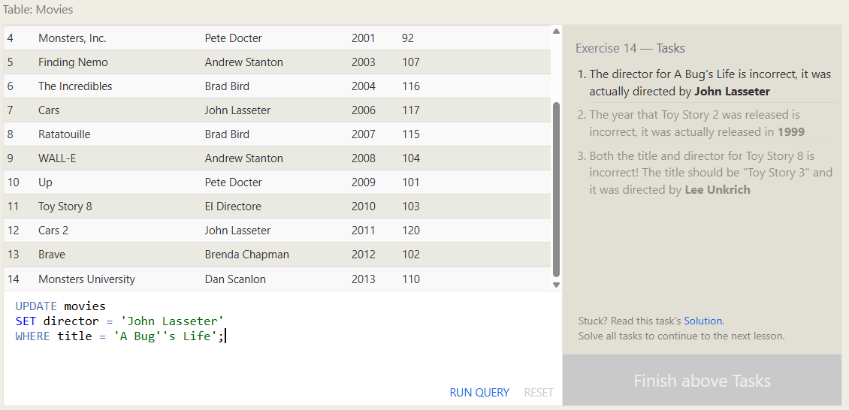
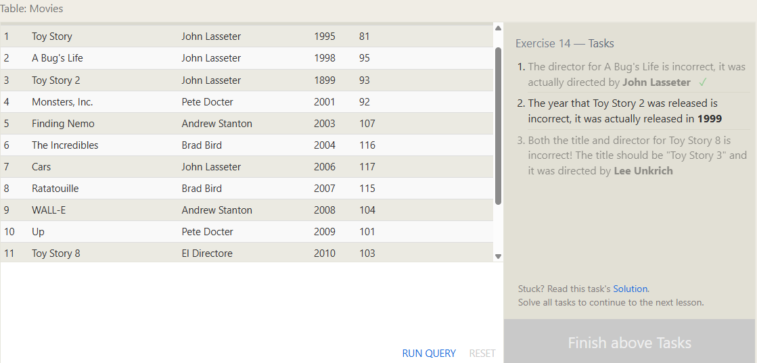
2. The year that Toy Story 2 was released is incorrect, it was actually released in 1999
UPDATE movies
SET year = 1999
WHERE id = 3;
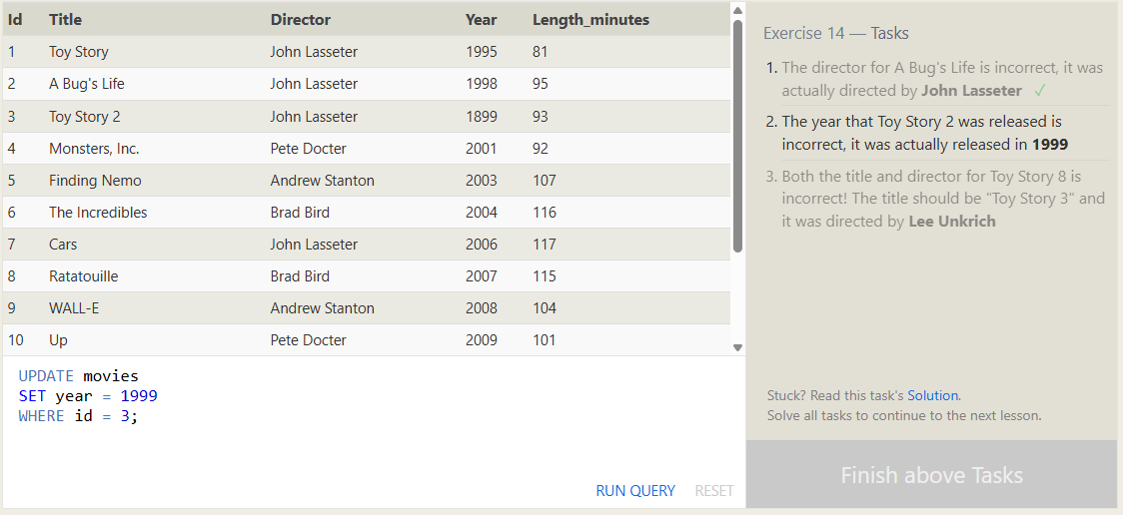
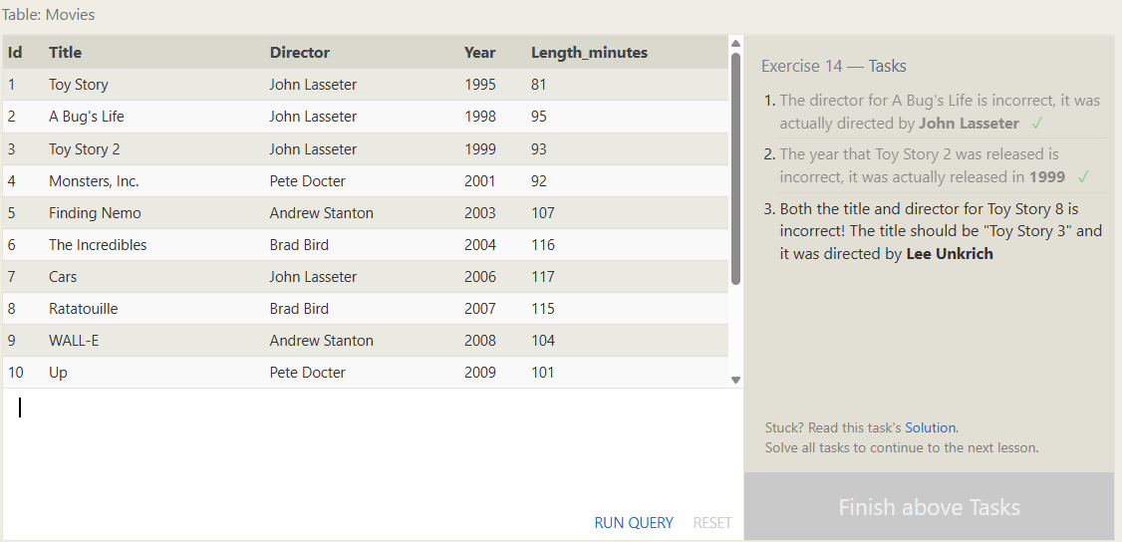
3. Both the title and director for Toy Story 8 is incorrect! The title should be "Toy Story 3" and it was directed by Lee Unkrich
UPDATE movies
SET title = 'Toy Story 3', director = 'Lee Unkrich'
WHERE id = 11;

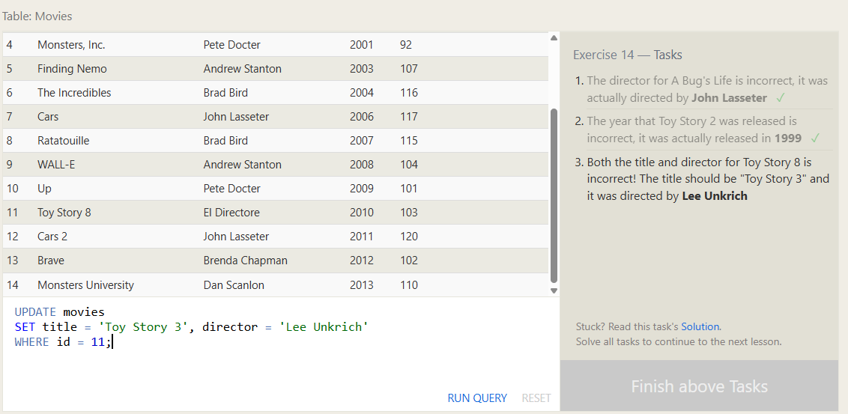
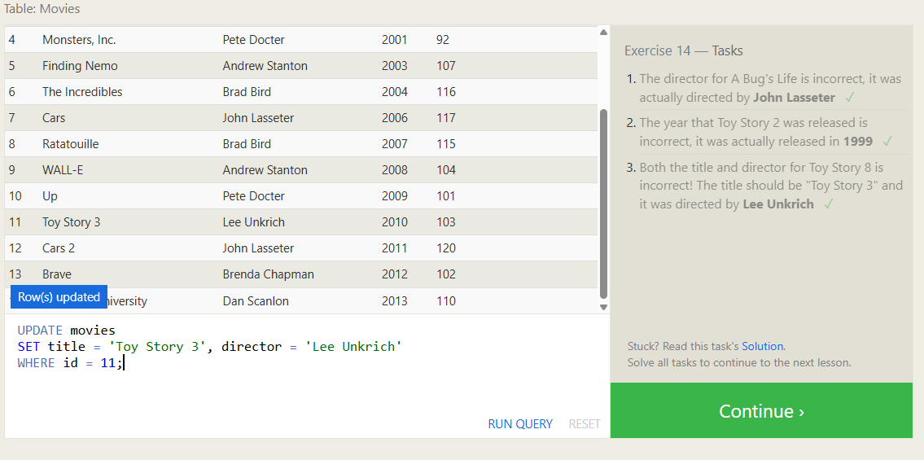

SQL Lesson 15: Deleting rows
1. This database is getting too big, lets remove all movies that were released before 2005.
DELETE FROM movies
WHERE year < 2005;
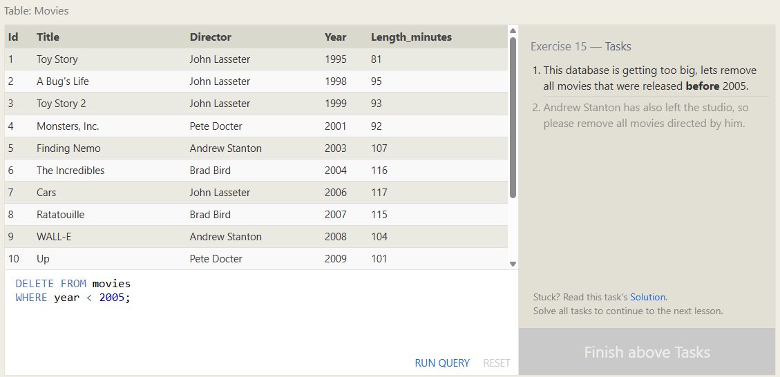
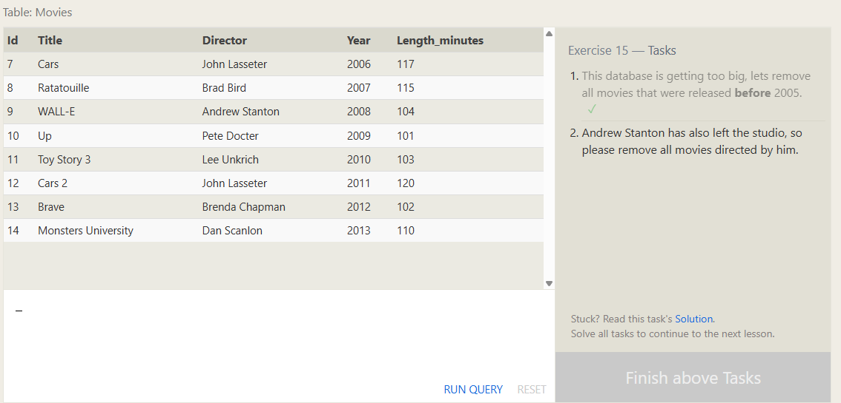
2. Andrew Stanton has also left the studio, so please remove all movies directed by him.
DELETE FROM movies
WHERE director = 'Andrew Stanton';
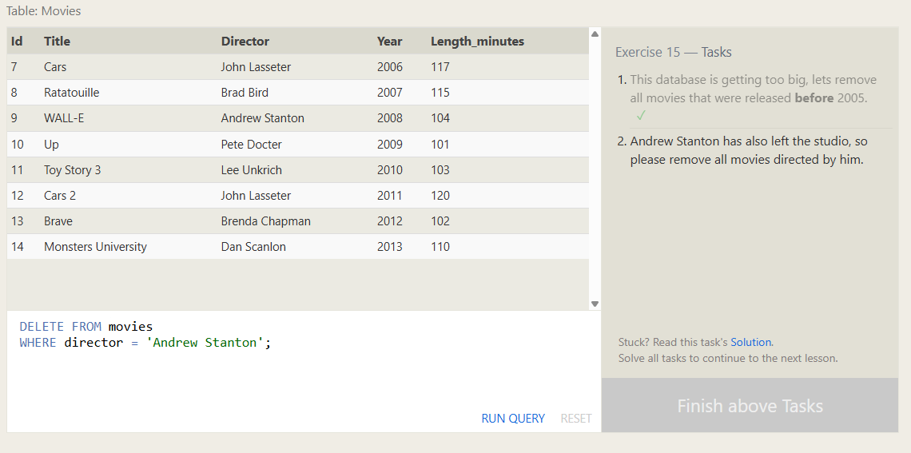
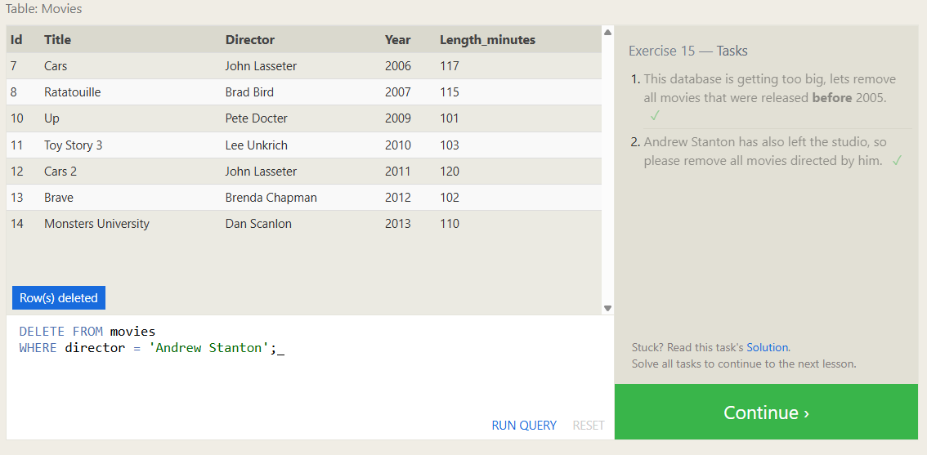

SQL Lesson 16: Creating tables
1. Create a new table named Database with the following columns:
– Name A string (text) describing the name of the database
– Version A number (floating point) of the latest version of this database
– Download_count An integer count of the number of times this database was downloaded
This table has no constraints.
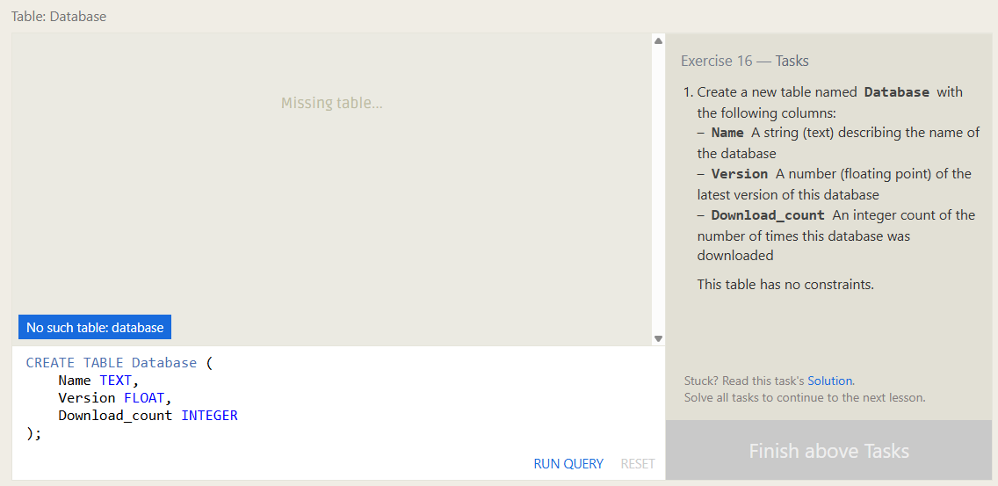
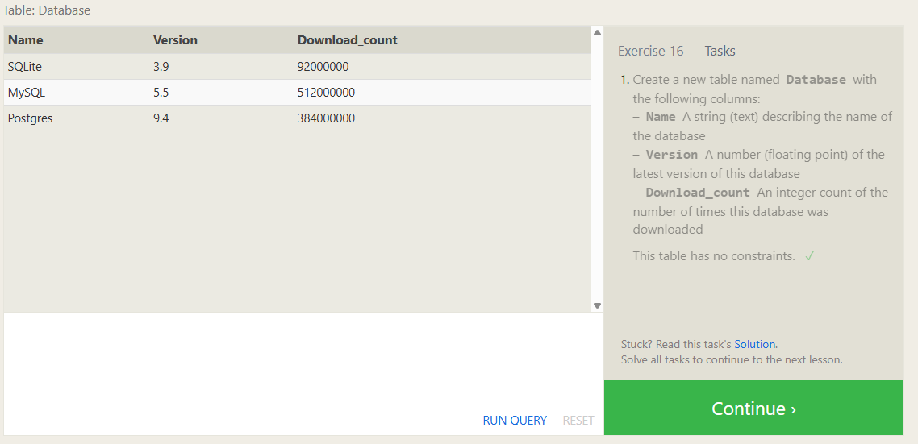

SQL Lesson 17: Altering tables
1. Add a column named Aspect_ratio with a FLOAT data type to store the aspect-ratio each movie was released in.
ALTER TABLE movies
ADD Aspect_ratio FLOAT;
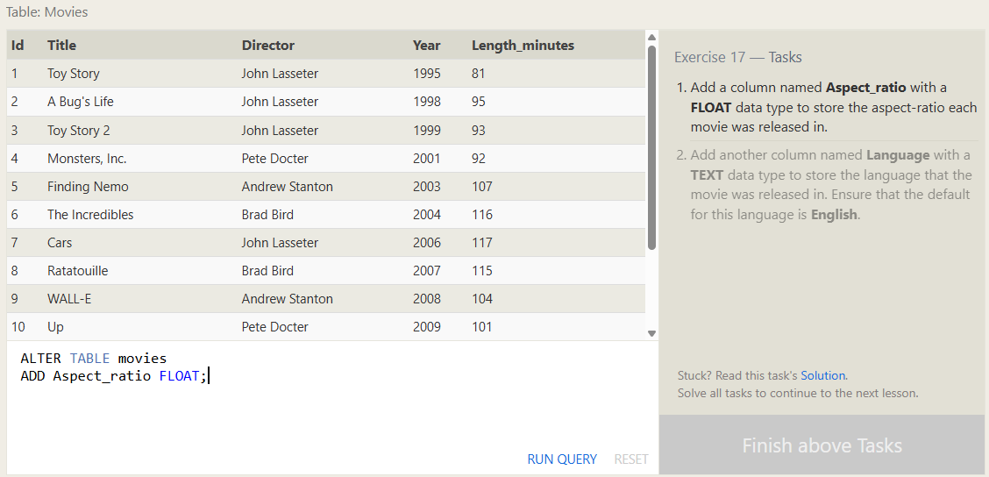
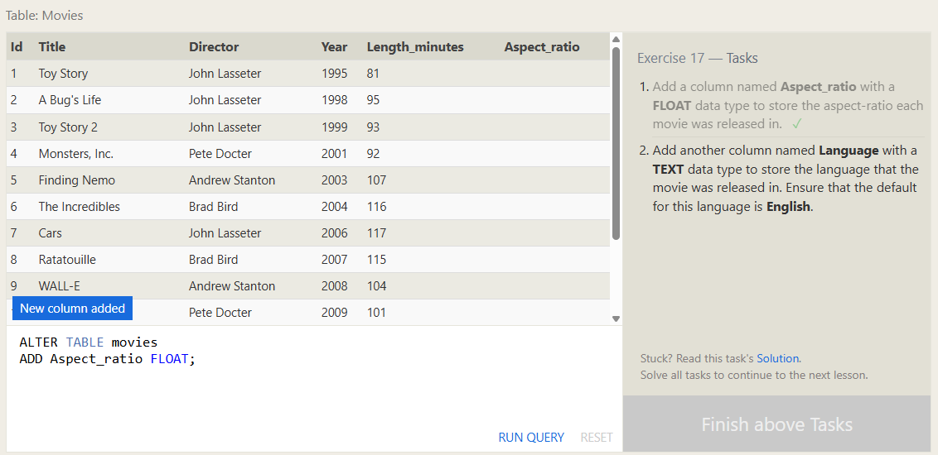
2. Add another column named Language with a TEXT data type to store the language that the movie was released in. Ensure that the default for this language is English
ALTER TABLE movies
ADD Language TEXT DEFAULT 'English';
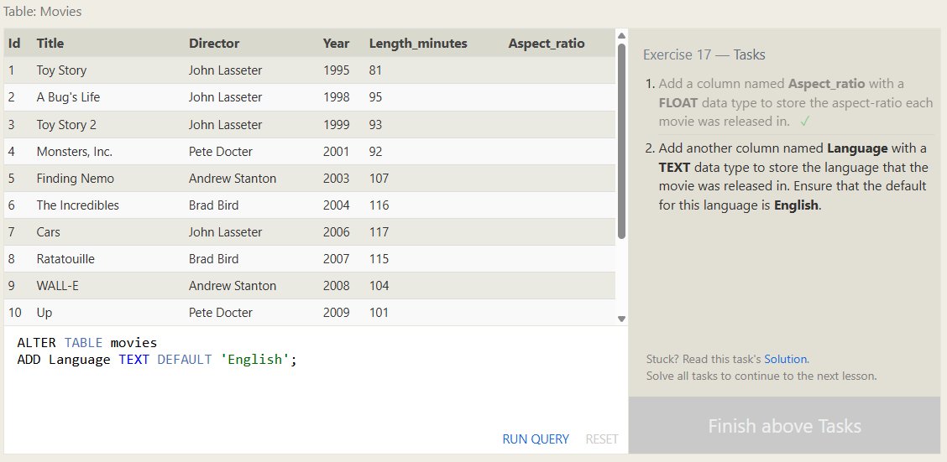
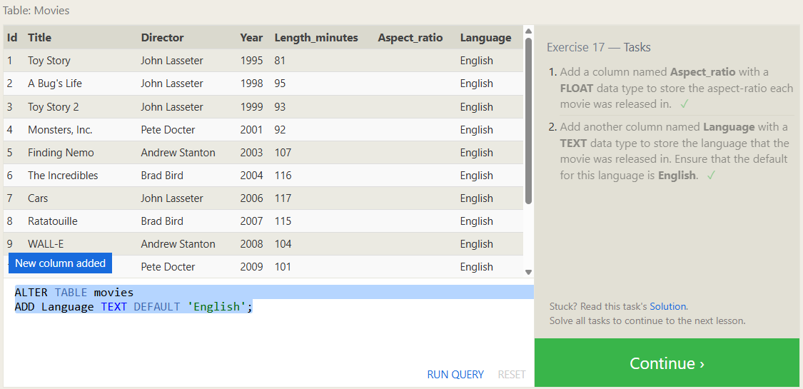

SQL Lesson 18: Dropping tables
1. We've sadly reached the end of our lessons, lets clean up by removing the Movies table
DROP TABLE movies;
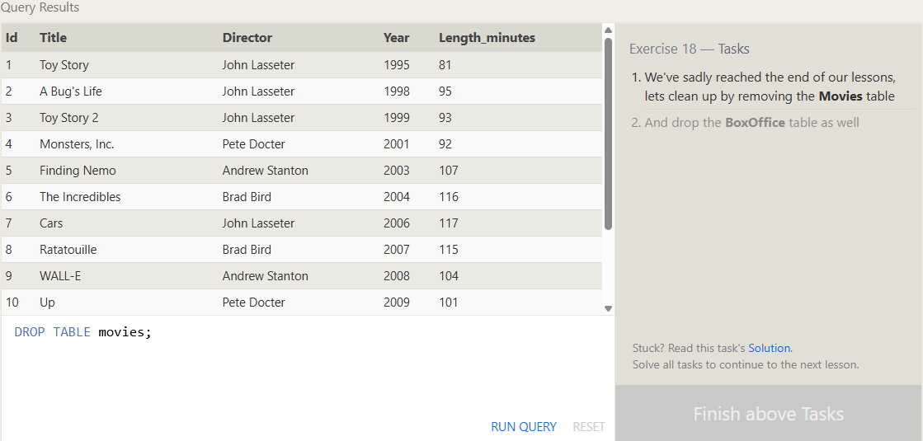
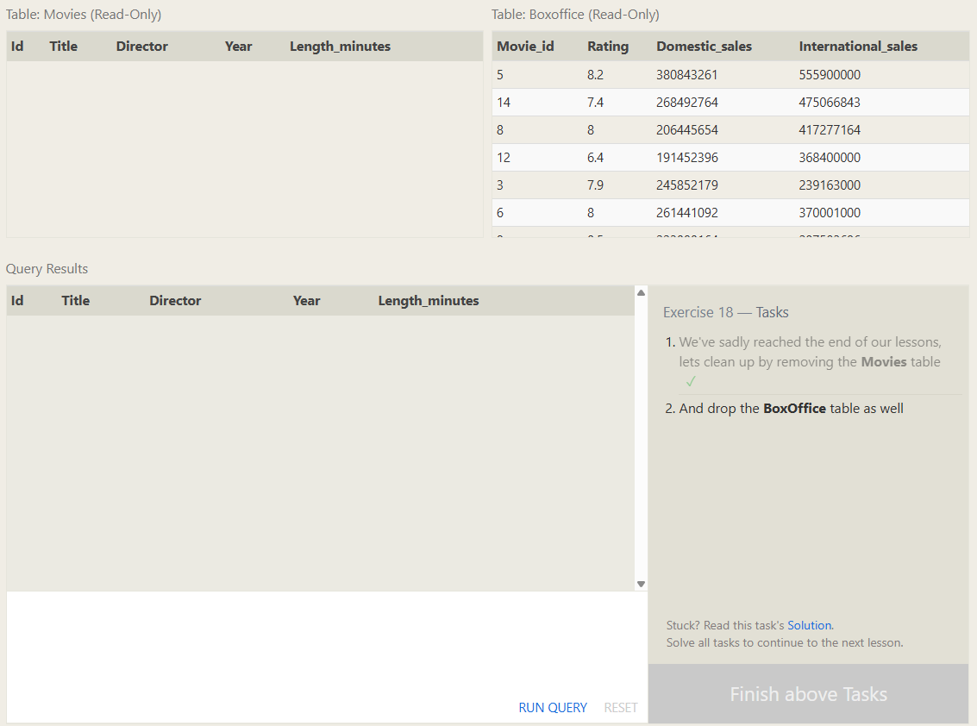
2. And drop the BoxOffice table as well
DROP TABLE boxoffice;
